PRACTICAL WEEK – 7 TASK 1: Write a program that prints the addresses Of code, global, static, heap, and stack variables. Analyze the Linux process address space layout and explain each memory segment
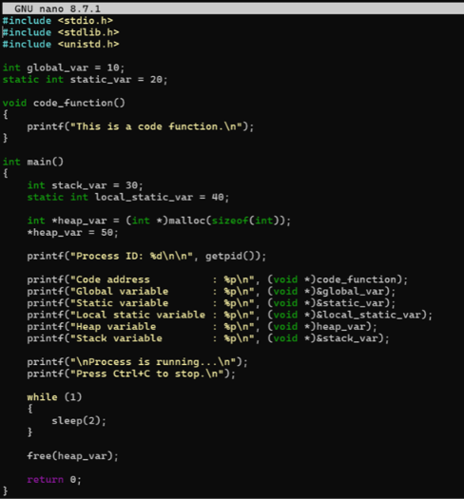
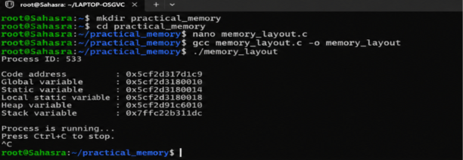

TASK 2: Make use of the /proc//maps file and memory analysis tools to study the memory organization of a running process. Prepare a report explaining virtual memory mappings.
